CS 348 – Human Computer Interaction – Spring 2009

Final Project
Online Self Services for Students

Authors: Renee Carmichael, Melissa Chiles, Alice Crosara, Emily Nathanson Jeremie Simon, Katy Wood
Editor: Renee Carmichael
Prof. Roda, in collaboration with the Computer Centre
Note: for each section only the main author is reported, in general all students in the class have contributed to all sections.

Abstract

Table of Contents
1 Project Drivers 3
1.1 Project’s objectives (Katy Wood) 3
1.2 Users and others stakeholders 3
1.2.1 Users (Renee Carmichael) 3
1.2.2 Other stakeholders (Melissa Chiles) 4
2 Requirements analysis 5
2.1 Introduction (Renee Carmichael) 5
2.2 Diary study (Alice Crosara) 5
2.2.1 Introduction 5
2.2.2 Method 6
2.2.3 Results 6
2.2.4 Discussion 9
2.3 Comparative study (Jeremie Simon) 9
2.4 myAUP usability study (Katy Wood) 12
2.4.1 Introduction Introduction 12
2.4.2 Results 13
2.4.3 Discussion 14
2.5 Focus group with students (Alice Crosara) 14
2.5.1 Introduction 14
2.5.2 Method 14
2.5.3 Results 15
2.5.4 Discussion 15
2.6 Students interviews (Emily Nathanson) 17
2.6.1 Introduction……………………………………………………………… 17
2.6.2 Method. 17
2.6.3 Results 18
2.6.4 Discussion 23
2.7 Other stakeholders interview (Melissa Chiles) 24
2.7.1 Introduction 24
2.7.2 Method 24
2.7.3 Results 25
2.7.4 Discussion 26
3 Requirements (Renee Carmichael) 27
4 Prototype 28
4.1 Approach (Emily Nathanson) 28
4.2 Working prototype and Screenshots (Jeremie Simon) 29
5 Appendix……………………………………………………………………………………..30

Project Drivers

Project’s objectives (Katy Wood)
For this project, we would like to Help Enterprise Resource Planning with identification of requirements for student self services. This project was also used as a way of learning how to design interfaces for our CS348 class. Our requirements for the project include functional requirements and presentational requirements in order to gain efficiency and user enjoyment. Our main challenges were working with the organization of the website to try and find the most professional and effective layout of the available online services. Many students, including the class, were unaware of many of the available student services on My.AUP. We needed to create a prototype more accessible to all stakeholders (including current students, faculty, prospective students, parents and visitors). To do, so we used this project to get stakeholders involved in the process. We gathered information from our stakeholders and used this to develop a requirements list.

Our limits with this project were small. We were not considering budget at the time and therefore included all ideal services in our prototype. The project is very large, so our prototype only concentrated on student services. We have only have a mock-up prototype.

To elicit requirements and design our prototype we collected data through multiple forms of analysis (see section 2) and have since developed a list of requirements for the new online services.

Users and others stakeholders

Users (Renee Carmichael)
We mainly focused on the students as the users of this website. AUP is made up of around 100 different nationalities. These students are majoring in one of 13 majors and one of 8 graduate programs. Aside from permanent students, AUP is also home to many visiting students that come to AUP for a semester or a year. The student body is also made up of many transfer students that come to AUP after experiencing another university. As such, AUP is a community in which there is constant flux in students as they come and go for different amounts of time. As the campus of AUP is composed of several buildings in the 7th arrondissement of Paris, the location of students is not centralized and often travel is needed to reach a desired building and/or service. The students also come from different backgrounds, which entail different experiences with user interface systems.

In order to account for these users in the various experiments that we have conducted, we decided we needed to include as diverse a population as possible. This can be seen the samples for the focus groups and questionnaires. We have also attempted to account for all the different student populations by conducting several different types of experiments in hope that these different experiments will help to reveal the different ideas amongst such a diverse population.

As a result of our experiments and the characteristics of the users, our final design is one that attempts to take into account a diverse population. This includes not only taking into account the different majors, nationalities, and languages, but the very structure of AUP as a university within a metropolitan city as well.

Other stakeholders (Melissa Chiles)
The my.AUP website not only affects students but other members of the AUP community. The Registrar plays a large role in the university and would greatly benefit from this project. Electronically animating the majority of the services they perform for students would greatly cut down on the foot-traffic in their office and increase the efficiency of their job by allowing them to focus on other priorities and spend less time on menial task. The majority of the service that students come to the Registrar for would better server both parties if they were available on the my.AUP website, like registration. The registrar can help contribute to the requirements by giving us an understanding of the services that they perform for students and by understanding these we can better help to adapt them to the my.AUP site.

Another stakeholder in this endeavour is the ITS department, they will be pivotal in the helping with the technical logistics of the my.AUP site. They will benefit from out project by getting a better understanding of what the students need. With this knowledge they will be able to better design the site to serve the students. The Bursar, Career, Academic Resource centre, and Academic Affairs office are also groups with an invested interest in our project. All of these offices would be more efficient if many of their services were available online for students through the my.AUP site. Some of these offices are out of touch with student’s needs and could help contribute to the requirements by giving us a better idea of what they do, so we could help bridge the gap between students and them via the my.AUP site.

The Housing office could greatly benefit from this project by incorporating housing offers online. It would approve the efficiency of placing students in housing in a more timely fashion and would help better organize appointments with students. The bookstore would also gain from this venture by cutting down the foot traffic during the beginning of the semester by selling the books online. The books could be sold and purchased online and would be able to be picked up at the bookstore. These two stakeholders can contribute to the requirement analysis by defining what their most time consuming encounters are with the students, so we have abetter understanding of which of their services should be animated online.

Requirements analysis

Introduction (Renee Carmichael)
In order to produce a list of requirements to be included on the final prototype and eventually the final implemented version of the website, we have conducted six experiments. The first experiment we conducted was that of a diary study in which we recorded for a week our current use of the my.AUP website. This was a good beginning point as it helped us to gain a better understanding of our own relationship to and thoughts about the website. Once we had a general understanding of my.AUP through the diary study, we conducted a comparative study of my.AUP with other university websites in order to further our understanding of my.AUP’s strengths and weaknesses as well as to help brainstorm ideas for our further studies. We then conducted Questionnaires with AUP students in order to gain an understanding of how the rest of the AUP population uses my.AUP. We furthered this by a focus group with four AUP students to gain even more details about the user’s experience of my.AUP. We also conducted a my.AUP usability study in which we counted the clicks that it took for AUP students to access certain elements on the website. This is important in including more quantitative data in our study. Finally, we conducted an experiment by doing a focus group and interview with the staff stakeholders of the website. We felt this is important as it helps us to gain another perspective on the project as a whole. These experiments helped us to create scenarios in which we can illustrate the proper use and design of the website according to the requirements that we discover. Here is an example of a scenario:

John Doe a junior at AUP is horrified by the photo visible on his my.AUP account, he wants to change it and update his information because his permanent address in the United States has changed. He logs on to my.AUP and goes to his Account and navigates to the My Profile section and clicks on the button that says edit right under his photo. There he’s able to upload a new photo of himself and navigate to the biography section and change his contact information, which includes his permanent mailing address. The new photo uploaded will be printed on John Doe’s ID card next time ID cards are distributed (which is the beginning of each semester). The program will be designed in such a way that only a head shot will be able to be uploaded, this way their won’t be any concerns about inappropriate or offensive photos being uploaded.

The experiments and scenarios are thus tools that help us to create requirements that relate to the users of the site and that can produce an effective, user friendly, and efficient university website.

Diary study (Alice Crosara)

Introduction
The CM/CS 348 class was interested to see what the average AUP student’s process was in using these services and how it could be improved. Therefore, a diary study was used to begin deconstructing the current system. What types of services are needed for an AUP student to function at AUP? Was the information available in the right place and at the right time? How complicated was it to access these services? Is it something that can be easily remembered? What was missing? Based on the analysis of these diary studies, this paper will attempt to come up with various conclusions and requirements necessary to create a more practical and efficient system.

Method
Why use a diary study? This method considers the perspective of the system’s user: how do they access the information? Where do they access it? How long does it take? Etc. It also helps to develop a list of terms that are understood by the users, thus allowing the developer to avoid using complicated jargon that can easily be misunderstood. Another aspect of the diary studies includes the user’s ability to make note of possible improvements, which might otherwise be overlooked for forgotten.

The diary studies were performed in the time period of one week. Students were given a table to fill out, in order to ensure continuity and consistency. The table included the following relevant information in order to reach our objective (see Appendix 5.1):
- Date and time (is information accessed during university hours or not etc)
- Location (this is important to see if information is available to students at home as well as in the different buildings)
- Access (important to understand how information is obtained and whether this could be added or not to the AUP web services)
- Information accessed (important to understand what services are actually needed by AUP students)
- Availability (illustrates problems and inefficiencies)
- Problems/comments (allows further discussion to get an idea of terms, what users think, and more details about their experience as a whole)

Results
Organization of combined diary studies:

# | User-task | Desired Function | Comment
1/7 | Accessing multiple AUP e-mail accounts | Logging out or switching users without having to close the internet session.
2 | Approving forms | All forms should be available online with features allowing students and/or faculty to easily complete, submit, and approve them.
 |  | Send form for approval to appropriate person(s) automatically (following the necessary chain of approval). Keeping the student informed. | Security is important.  Feedback to students on whereabouts of forms.
 |  | Final notification to all
3/25 | Room Reservation | Keep service of room reservation, make it searchable and automatic.  ALL rooms should be accessible and accounted for. | Human overriding USABILITY
4/15 | Consulting the Internship/Career Database | Make career database more visible (create a quick/direct link), make it searchable, include all offers | Design
5/11/  22/24 | Blackboard access and use | Make access to blackboard easy (have a good quick link from MY AUP) and allow easy downloading of assignments from any computer.  There should be article links directly attached to the online syllabus. | Usability/design
6/17 | Checking transcripts | Allow students to easily see all of their personal information | Evident link with enhanced security settings, such as added password questions, would be needed.
 |  | Have support for degree-check either automatic or supply the forms so students can do it by themselves | Design
8/9/10 | Access faculty and various student services offices (including student affairs, the registrar, the bursar, etc) | Make information for accessing faculty easily available (searchable database, directory) Webmail is good for certain causes (uncomplicated professors names) but needs to have improved search facility (ex. Search by course) | Usability
12/14 | Online Library | Accessing articles (varying levels of understanding – a quick tutorial link could be helpful). | Design/usability
13 | Campus Directory | All buildings and office locations should be clearly identifiable and accessible.
16/20 | Checking AUP email | Could be more evident on myaup (direct link webmail.aup.fr currently easier to use) | Design
18 | Academic Calendar | Should be easy to locate on myaup. | Usability
19/26 | Class schedule | Students should be able to easily access their own schedule first and foremost. (perhaps with a quick link). | Design/usability
21 | Student hard drive | Easily accessible from myaup | No change necessary
23 | ARC tutor schedules | Online scheduling should be available | Design
27 | Advisor Information | Should be easier to find. | Usability

One of the key words that repeatedly arose during the qualitative analysis was “usability.” Students are having trouble finding certain links and once they do they often aren’t able to find the direct information for which they are searching. The other main issue is the “design” of the my.AUP site.

There is a clear gap between my.AUP and AUP homepage at aup.edu. If students are having trouble finding the information they need, they are often looking at the wrong site. While faculty contacts and office locations can be found at aup.edu, personal student information is found at my.AUP. Perhaps one action to take is to assess what each site is used for and either make a clear break between the two without overlapping information, or to join the two in a more cohesive manner.

- Most frequent activities used are: blackboard, room reservation, checking transcripts, and accessing the AUP email.
- How many students accessed information from home: All.
- How many students access information regarding location, website, grades, e-mail? All.
- How many participants were male, female? One male, four females.
- Which services need to be made more accessible? Blackboard and personal information including transcripts and career development information.
- How many students had difficulties with accessing the blackboard service? 3 of 5.
- How often did these students record problems concerning the AUP email service? 4 of 5.
- What are the main concerns with the services in general? Usability and fundamental design.
- Are the computer interactions easier or more difficult than human-human interaction? The human-human interactions are more time consuming than human-computer interaction.
- How often do these students use the computer services vs. telephone or person-to-person interactions? The majority of the services were accessed by computer, unless they needed specific signatures from faculty members.
- Which functions are most important to students on a daily basis? Checking blackboard, e-mail, and personal information including transcripts, academic standing, etc.

- How many times did a student have to change buildings to access information? 4 times – always related to getting signatures of approval from various faculty members.
- What information was not easily found? What was easily found?
  - Easy: student hard drive
  - Difficult: all others noted (*this signifies that the diary study concentrates on the negative aspects of the services consulted).
- How often do users need services at AUP? Approximately 3 times a day.
- Where is information accessed? The Grenelle computer lab and personal laptops were used most frequently in order to access information.
- Which tasks did not have online availability? Meeting with faculty for signatures, ARC tutor scheduling, and signing up for courses are the only tasks that could not be completed online.

Discussion
Below is a list of requirements that arose of the results of this experiment.

REQUIREMENTS
Accessing Multiple AUP e-mail accounts on one Internet session. | CS=3 CD=2 P=1
Obtaining forms and faculty approval online. | CS=4 CD=4 P=4
Make online Room Reservations | CS=3 CD= 3 P=3
Quick-link and clear link to Career/Internship Database | CS=4 CD=4 P=4
Quick-link to blackboard and more user friendly | CS= 3 CD= 4 P=3
Checking personal academic profile: students should see their personal information. | CS=3 CD=4 P=4
Library tutorial link. | CS= 2 CD=2 P=1
Campus directory of buildings and Faculty offices (including phone numbers, addresses, and map link). | CS=3 CD=3 P=3
Direct link for AUP e-mail. | CS=3 CD=3 P=3
Direct link for Academic Calendar | CS=3 CD=3 P=2
Clear presentation of class schedule | CS=3 CD=3 P=3
Quick access to student hard drive | CS=4 CD=2 P=3
Online ARC tutor scheduling. | CS=3 CD=3 P=3
Advisor information easy to find and alter. | CS=3 CD=3 P=2

Comparative study (Jeremie Simon)

2.3.1 Introduction

To make this comparative study, we looked at the content of each website: how was the information organized and how accessible was it? We looked at three university websites: University of San Francisco, University of Wisconsin Madison, and University of Washington.

To make the comparative study better, we tried to understand these university websites according to the size of their campus, the importance of the city and the diversity of the programs offered.

2.3.2 Results

University of San Francisco:

-The university counts 8447 students and is located in San Francisco, a 800,000-inhabitant city.

-The university is particularly recognized for its law, business and management programs

-USF is ranked in the top 20 of the best universities of the US

General comments on MyUSF:

I could not access myUSF, however, I had access to a demo.

The website is very well organized which makes the information easy to access.

MyUSF id divided in only 6 rubrics: Students, Admission, Services, Community, Calendar and Personal Information.

The rubric Admission and Community might be confusing (why would a student would be interested in its admission since he is already in the university?).

Design:

The design is pretty much the same everywhere. However, each rubric has its proper colors, which helps to quickly memorize the way the information is organized.

Information:

-The user is not overwhelmed by too much information.

-And information belonging to one rubric is never repeated in another rubric

Conclusion:

There are no particular problems, no superfluous information with myUSF. Everything is made clear and simple

University of Wisconsin-Madison:

-The university counts 42000 students and is located in Madison, a 500,000-inhabitant city.

- The UW was ranked 17th among world universities and 15th among universities in the Americas.

General comments on MyUW-Madison:

-The website is divided in 6 rubrics, which are: Home, Academics, Finance, Services, Work Record, My Page.

-This division makes everything perfectly clear when one is searching something

Design:

The design is the same all long the website and the colors are the same from one rubric to another. However the possibility to edit the space to make it particular to each user seems particularly interesting.

Information:

-The content of the website is more important than the content of MyUSF, more services and information are offered which is a consequence to the important difference in terms of number of students in the two universities.

-Pages are not overloaded with information however.

Weaknesses:

-Some information like the weather might seem useless.

Strengths:

-My webspace

This gives you how much space is left on your hard drive

-Customize your page

Possibility to customize your pages depending on your personal needs

-Live chat

There chat everywhere, on every social network and even on your mailbox; but still, it’s always nice to have one.

Lost and found

Critics:

Except that there is no point to have a rubric myPage and a rubric home since the both display more or less the same information, the rest of the website is really good. The design is sober but efficient and the possibility to edit the web pages is really interesting.

University of Washington:

-Washington University is located in Seattle a city of 600,000 inhabitants
-According to Wikipedia, Washington University is approximately 42 times bigger in terms of students number than AUP and has a campus of 3 km2.

General comments on MyUW:

The design of the website is very simple and sober. We find the same color code throughout the website.

Logically, MyUW provides more information to the user than My.AUP does. MyUW provides a huge amount of information, which is not always a good point.

Weaknesses:

-Some of the information is very hard to access especially when you are not familiar with that kind of huge website.

-Pages are overloaded which makes things difficult to find

-The information found is often redundant
(One can find a list of the campus events on almost every rubric.)

-Some of the information provided would be useless on My.AUP
(e.g. Theater program, Parking information, Cultural program of the different places in the city, address book and phone book of every student who lives in the campus)

Strength:
-Consequently to the size of the University MyUW provides more specific information and seems to be updated more often.
-MyUW provided some very interesting information well designs that My.AUP does not have.
( I really like the idea of the big picture for each rubric.)

Conclusion:

As strange as it may seem when one first look at MyUW, the difference of the amount of information provided between the two websites is not significantly different. The main difference of the two websites lies in the choice they made in the design and presentation of the information. On one side, Washington University decided to gather and center all the information available on the campus on MyUW which creates a huge website with (too) much information. On the other side, AUP decided to divide its website into two distinct part which reduces the amount of information available on My.AUP. One can find almost every information given by MyUW (except the information that would most make sense on the AUP website like “Parking Option”) on the AUP website or My.AUP so the user has to work with two websites instead of one. This makes for confusion between the two sites, but less information overload (as is found on MyUW).

myAUP usability study (Katy Wood)

Introduction Introduction
The my.AUP usability study was designed as an experiment to test student’s knowledge of services through my.AUP and their ability to navigate through the system. Method
For this study, we designed an experiment and used AUP students as participants. The experiment consisted of students being asked to complete a task while experimenters counted and recorded the number or clicks and time (in seconds) it took each participant to complete the task, if completed. Following are the final instructions for the study:

For this observation, students will be logged into my.AUP and asked to perform the tasks listed on the table. One of the two observers will count the number of clicks it takes for the student to reach the destination and time how long it takes for the student to get to the destination. Please ask the student to perform one task after another, without taking them back to the main my.AUP page. Please note that clicks include scrolling and hovering over drop menus.

Students were given four tasks:
Task 1: access a file saved in your student drive through my.AUP,
Task 2: locate your unofficial transcript,
Task 3: find where you can add money to your printing account,
Task 4: find your mailbox number.

Students were asked to go directly from one task to another while one experimenter counted the number of clicks and timed each task, and the second experimenter recorded any notes or comments.

See Appendix 5.2 for the study and the table of results.

Results
The following tables show the results for each of the tasks within the usability study.

In each table, the number of clicks is graphed on the x-axis and the time for each task is graphed on the y-axis. Each dot on the graph represents a participant. Within the graph, the lower left quartile (clicks < 4, time < 40sec) shows efficient time and number of clicks to reach the desired service. The upper left quartile (clicks < 4, time > 40sec) shows efficient number of clicks but slow timing, possibly due to slow internet connections or participant having to look for appropriate link to follow. The upper right quartile (clicks > 4, time > 40) shows inefficiency in time and number of clicks. Finally, the lower right quartile (clicks >4, time < 40) shows efficient timing for the tasks but an inefficient number of clicks.

Task one produced random results. While task two was more concentrated with lower numbers of clicks and less seconds, there were a few outliers that have brought the average up. Task three has varying times but most participants used similar numbers of clicks to complete the task. Finally, task four must have been the easiest. Other than a single outlier, task 4 has a very low concentration of clicks and times. Based on the results, it appears as though the tasks got easier as they progressed

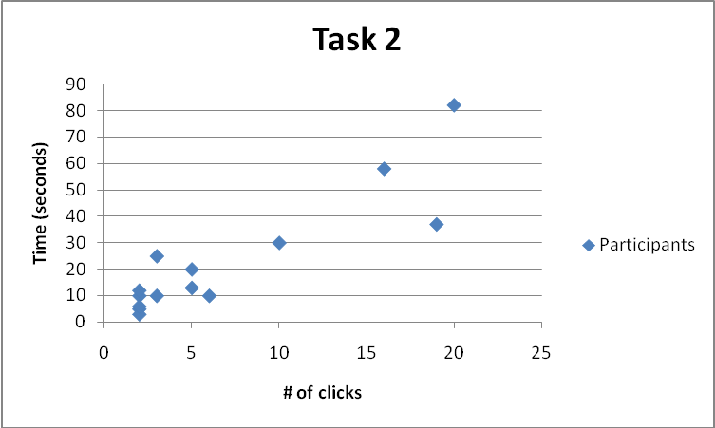
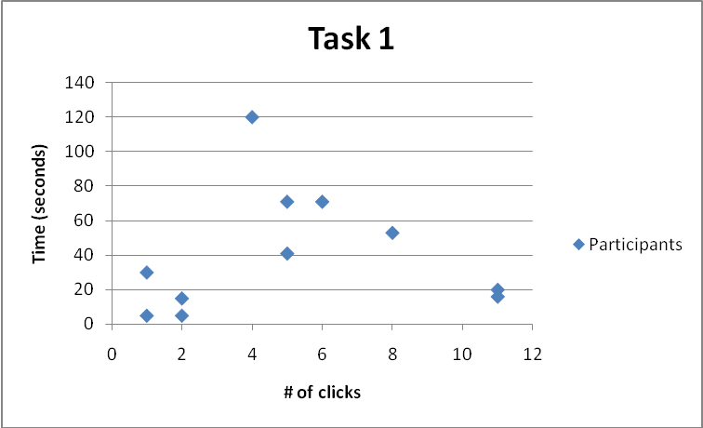

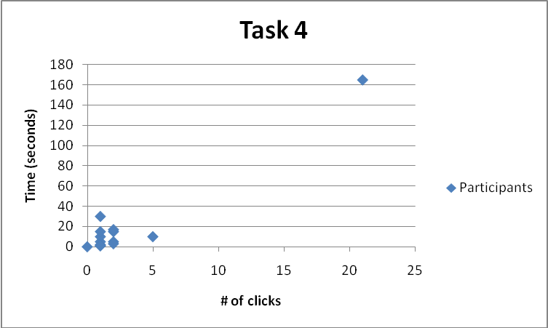
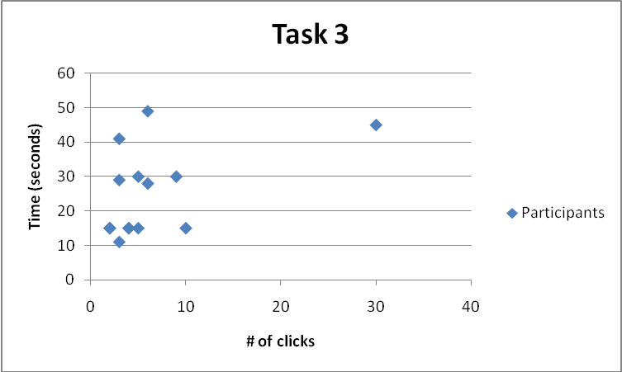

These graphs show quantitative results of how students performed on each task. Qualitatively, the graphs also show that, except for task 4, results were varied, showing that students had very mixed knowledge about how to complete the tasks. This means that, even if some students are aware, or generally knowledgeable about navigating through service systems, not all students are aware enough. Ideally, when it comes to student services online, we are looking for most students to be able to quickly complete the tasks, regardless of how familiar they are with the services. For task one, two students were not actually able to complete the task, showing that even if the service is made known to the students, not all were able to find it, even through trial and error.

Discussion
For task one, only 4 of the 12 participants were able to complete the task with an efficient amount of clicks. For tasks two and three, only 7 of the 14 participants were able to complete the task with an efficient amount of clicks. For task four, 12 of the 14 participants were able to complete the task with an efficient number of clicks. This efficiency in task four may be due to the fact that the mailbox number is on the main profile page and can be found in more than one place. The other tasks, however, are more specific and are less accessible that finding one’s mailbox number. The one outlier in task four took a while to complete the task simply because he skimmed over the mailbox number on the page while he was looking and got confused.

Based on the results and comments from this study, most of the participants were able to complete the task by reasoning, trial-and-error and simply searching for the service. This tells us that the tasks are not difficult to complete once they are asked, but most participants had no idea the service existed on my.AUP. Other comments from the students included that the headings were too small. While the organization of services may be logical, most services are not visible enough for students to be aware of them. This study’s results showed us mostly that the layout of my.AUP needs to somehow make services more obvious to its users.

Focus group with students (Alice Crosara)

Introduction
A focus group is a small group of people who meet together and provide answers plus opinions to some questions asked by a group leader. The objective of this focus group was to investigate the available student services and accessibility of My.AUP. The benefits of this focus group is that we will be able to use this information to re-create My.AUP so as to better suit the students’ needs at AUP. A pilot study was conducted to test the focus group, using the members of the CS/CM 348 class. From the pilot, it was clear that certain adjustments were needed, primarily the rewording of the script in order to keep it vague and open.

Method
The Students were asked open questions about My.AUP, its services and accessibility. They also completed a short survey about themselves. Two members of the CS/CM 348 class took notes during the course of the focus group session. The experiment was conducted with four students, three male and one female. See Appendix 5.3 for questions asked.

 | Student 1 | Student 2 | Student 3 | Student 4
Major | Film Studies | History | International and Comparative Politics (ICP) | ICP
Full time or visiting student? | Full Time | Full | Full | Full
# of Semesters | 1 | 6 | 5 | 6
Age | 19 | 20 | 19 | 20
Male/Female | Male | Male | Male | Female
Diff between MyAUP and aup.edu | Aup.fr is general AUP website and my.aup.fr is a more personalized version that allows you to log in. | My.aupfr is directed to the AUP community of current students and alumns. Has ads, classifieds, unofficial transcripts, student activities. | My.aup is particularly for students and seeks to provide students with all necessary information pertaining to their academic life at AUP. Aup.edu is primarily for the public. | MyAUP provides informational links to student email, its services and other student services, i.e. you can pay for your classes.

The focus group met in the ARC Classroom in the Grenelle building at 18h30 on April 16th, 2009 and lasted for approximately one hour. Two members of the CS/CM 348 class took notes during the course of the focus group session.

Results
The following is a compilation of the notes taken during the focus group.

The following is a compilation of the notes taken during the focus group.

Aesthetics:
Could use other colors
Could use more pictures or rolling pictures
Home page should have current pictures

First impressions of AUP via MyAUP and aup.edu:
- AUP site was easy to navigate and had good connection with it
- Better than other websites
- Went on planet website and looked at archives before coming to AUP
- Found aup on the Internet but felt like he had to come visit to find out what it was really like.

Current problems:
- The site should be a physical manifestation of student work
- Links to sga, other websites
- SGA and student media should be more present
- Classifieds should be more visible
- More information about 7th and AUP neighborhood online
- More information about Paris
  - Transportation: Link to ratp website
- Faculty information should be updated
- More control over personal record
  - Students would like full control over academic information: grades, GPA, etc.

Human-human interaction desired:
- Housing: have pictures and make appointments
- Degree check
- Carte de sejour

Improvements already made
- Getting better, changed, first page has webmail on side links more accessible
- Career development office and links
- The overall website is better: now webmail link on side, links more available.

Discussion
Most students found AUP through the website and by word of mouth.

Students like to see other students whereabouts and would like to see it taken further, for example, the Planet and ASM publications should have clear links on the website. They found that the website has an effective “academics” section, but the “student life” section overall is lacking.

How to make MyAUP more appealing for current students?
Why is it that students are constantly on facebook, twitter, myspace, etc? The key is updating information and accessing photographs of recent events. Another important feature is the groups function, where students can find updated information about events, new members, activities, etc involved with their school-related and/or extracurricular clubs (ex. Roots and Shoots, AUP Radio, Photography Club).
Requirements

Aesthetics must be appealing – including examples such as color scheme and recent photographs. | CS=4, CD=4, P=4
MyAUP and AUP homepage should include direct links to AUP student publications to showcase student work. | CS=4, CD=3, P=3
Should be a direct link to the SGA on both the MyAUP and AUP homepage so that students, faculty, administration, and parents can see what the SGA does (especially since large funds go to the SGA) | CS=3, CD=2, P=2
Faculty and student information should always be automatically updated. | CS=5, CD=5, P=5
There should be a clear link to AUP Classifieds. | CS=3, CD=3, P=2
There should be a link to the AUP area (the 7th Arrondissement), Paris transportation, “Paris Pratique” (primarily for visiting, prospective, and new students). | CS=3, CD=3, P=2
Students should have access to all of their personal academic information online. | CS=4, CD=4, P=4
Services such as Housing, a degree check, and the carte de sejour information/forms/approval should be available online, as well in person from the various offices (housing office, registrar, etc). | CS=3, CD=3, P=3

Students Questionnaire (Emily Nathanson)

Introduction
A questionnaire for AUP students was created in order to gain a better understanding of how AUP students currently use the my.AUP website. This student questionnaire is based around the various student self services that my.AUP offers, and thus it asks students to recount how they have fared so far accessing and utilizing these self services. The underlying goal is to see what AUP students like and do not like about the current my.AUP website. This will ensure that the appropriate changes can be made when recreating the current website so that the student’s requirements can be sufficiently met.

Method
Questionnaires are a well-established technique for collecting demographic data and users opinions about a specific topic. When designed correctly, questionnaires are effective at getting answers to specific questions from a large group of people. The student questionnaire we created begins by asking students to answer basic questions about their identity (age, gender) as well as their academic background and history at AUP. The remainder of the questionnaire consists of a variety of open-questions, closed questions, ranges and rating scales. (See appendix 5.4 for the questionnaire).

During the construction of the student questionnaire, the members of this class filled out the questionnaire themselves as well as the various updated versions of the questionnaire. The purpose of this was to perfect the questionnaire and make sure it not only made sense to us but that it would make sense to other students as well. Once the student questionnaire was officially completed and finalized each member of the class was instructed to find five AUP students to complete the questionnaire.

Users were observed indirectly through the completed returned questionnaire forms in order to gather the appropriate and necessary data.

Results
Below are graphical representations of the quantitative data/results regarding the profiles (academic background and identity) of the student participants that was obtained from the completed questionnaires
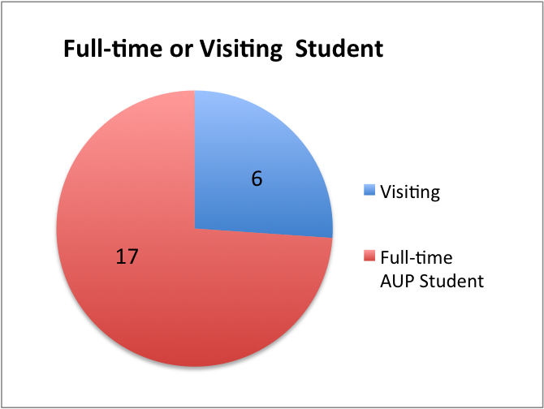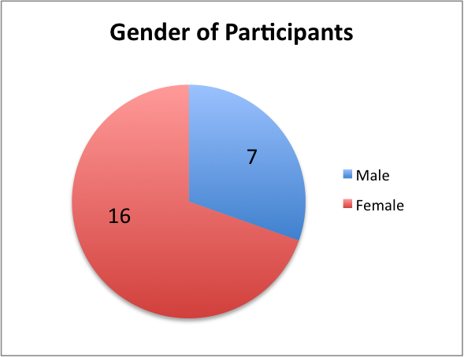

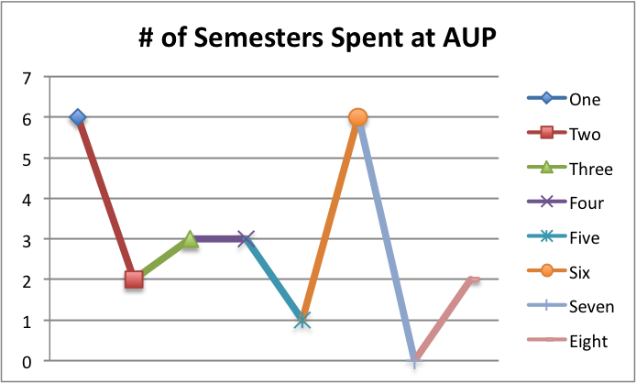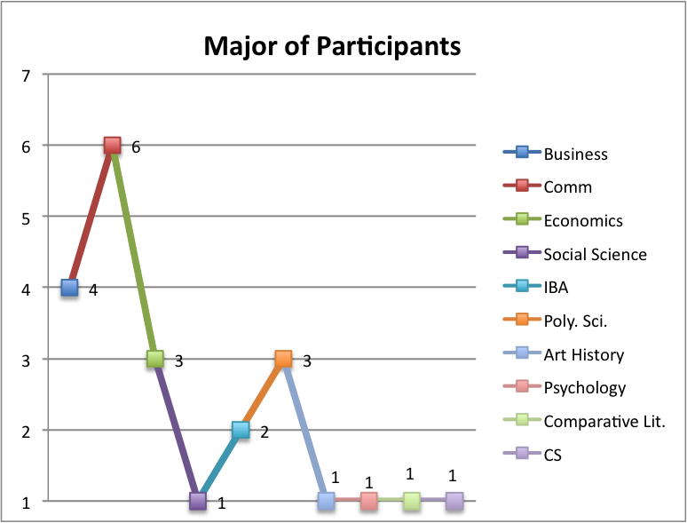
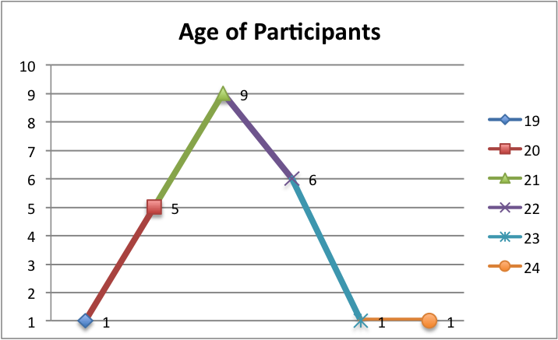

As depicted in the graphs above, the average age of the participants who completed the student questionnaires is 21, which is also the most common age. 74% of the all participants are full-time AUP students. The most common major among the participants is communications, followed by business. The participants were made up of 6 visiting student with the remainder of students being full-time permanent students at AUP. Lastly, approximately 70% of the participants were female.

Below is a graphical representations of the quantitative data/results that show the level that students agreed with statements that were posed to them about accessing information online and on campus, as documented in the completed questionnaires. The graph depicts interesting results regarding how students feel about the process of accessing information online verse on campus. For each statement that was posed, exactly eight participants, or 35% of the participants, agreed with that statement.
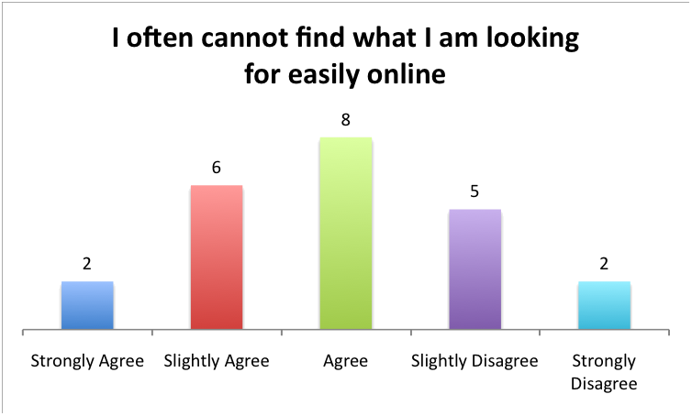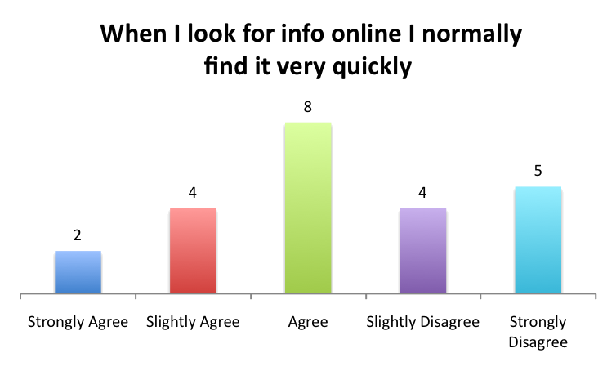
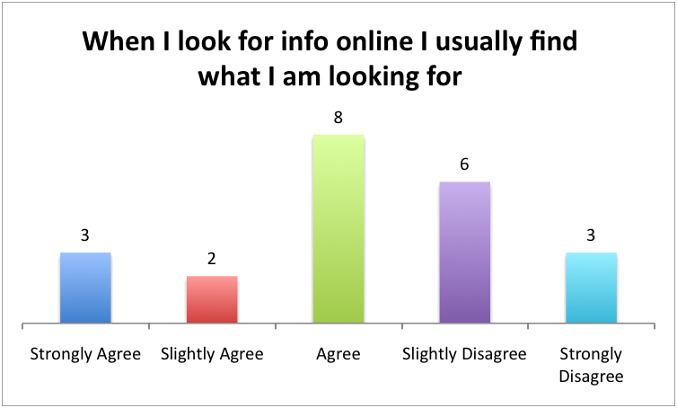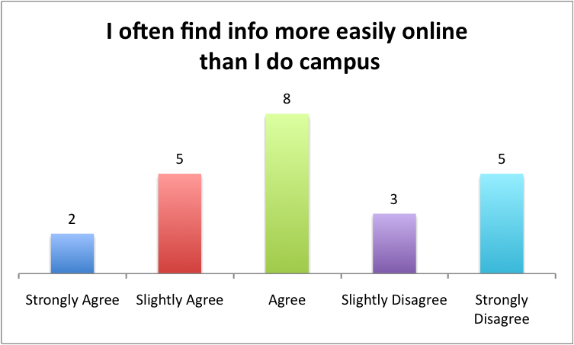

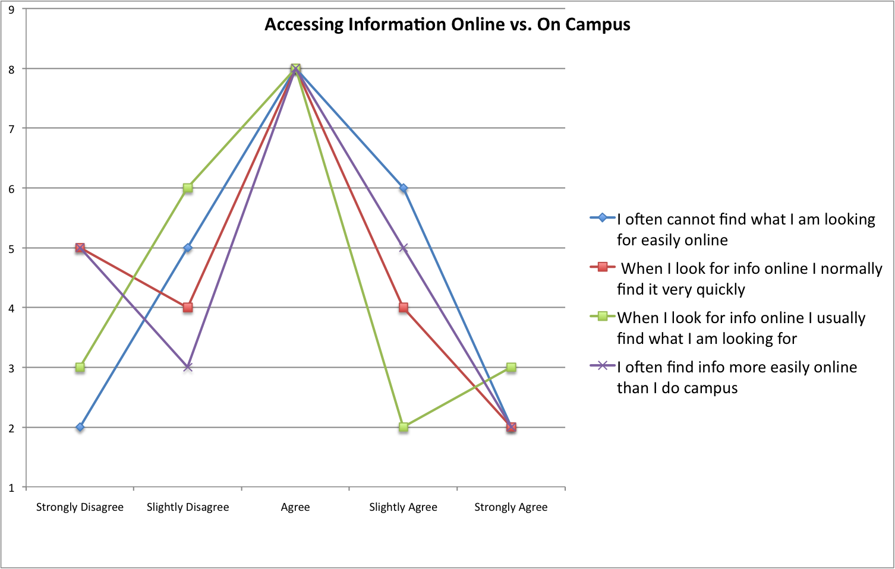
Below are graphical representations of the quantitative data/results received from the completed questionnaires. These graphs depict the frequency that students accessed self services through my.AUP. These services were specified and listed on the questionnaire.
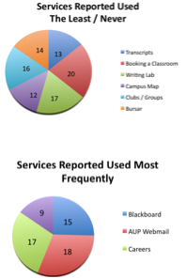

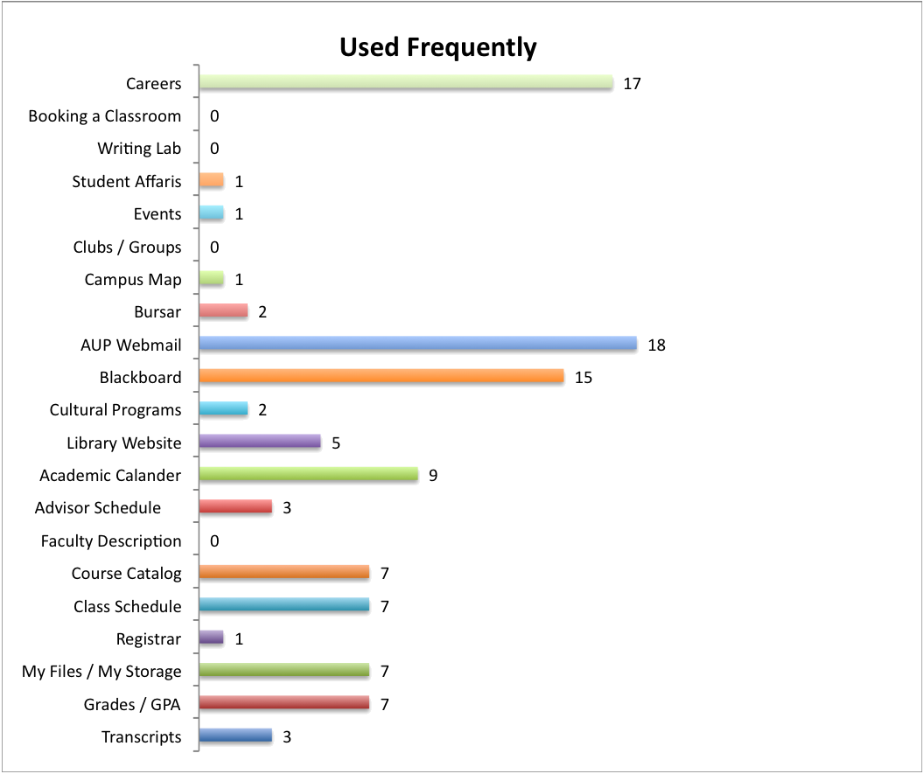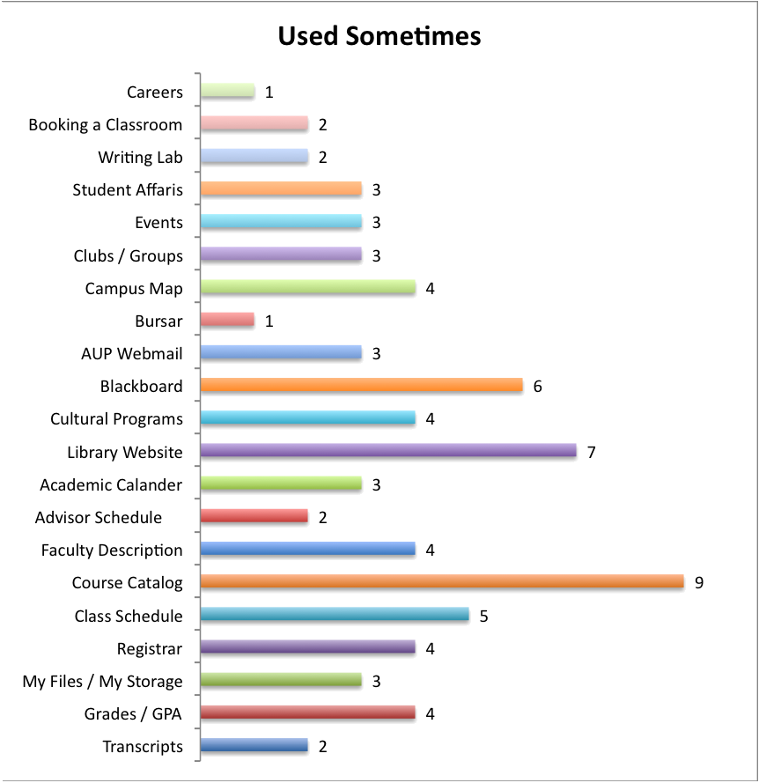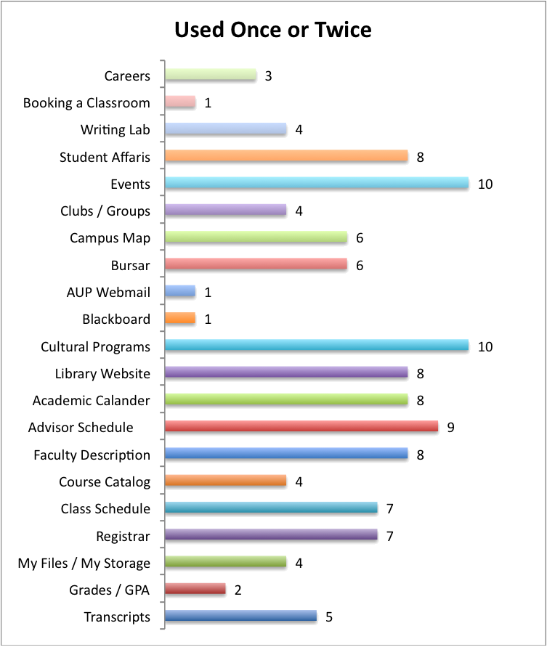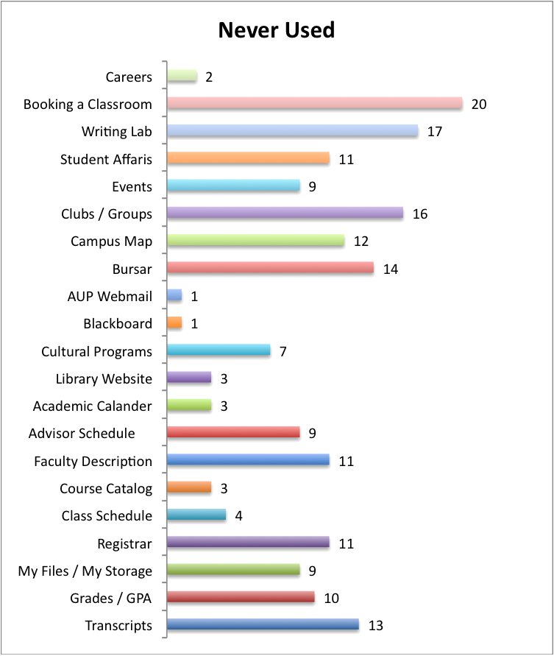

There are certain patterns that were detected among the responses of the participants particularly relating to the frequency of the use of student self services. In the two graphs above on the right some of these patterns are depicted, such as the services students stated they used most, blackboard, webmail, academic calendar, careers, and the services they used least, or never such as transcripts, booking a classroom, writing lab, campus map, bursar. Other more specific patterns were noticed among the responses particularly those of the 6 visiting students. Other patterns were noticed when these responses of the visiting students were juxtaposed with the responses of 9 full time students who have been at AUP for 5 semesters or more. In terms of the complete list of students services available online through my.AUP all 6 visiting student reported that they have never used 8 of the 21 listed services: transcripts, registrar, grades / GPA, writing lab, bursar, booking a classroom, clubs/groups, and careers. Conversely, there is not a single service that all of the permanent AUP students have never used. 7 of the 9 fulltime students reported they have never booked a classroom, but the remaining two full time students admitted to using this service sometimes. Of the 21 listed services, there were only 4 services found to have been used at least once by all 6 of the visiting students; blackboard, webmail, library website, and the course catalogue. For the full time students there was also only 4 student services found that all 9 full time AUP students have used at least once through my.AUP; grades/GPA, class schedule, academic calendar, blackboard.

Below is a graphical representations of the quantitative data / results received from the completed questionnaires regarding the question, “which student services, not already offered through AUP, would you would like to be available online the most”. The results displayed are the averages that the students ranked each self service based upon a scale of 1 -10, (1 being the highest and 10 being the lowest)

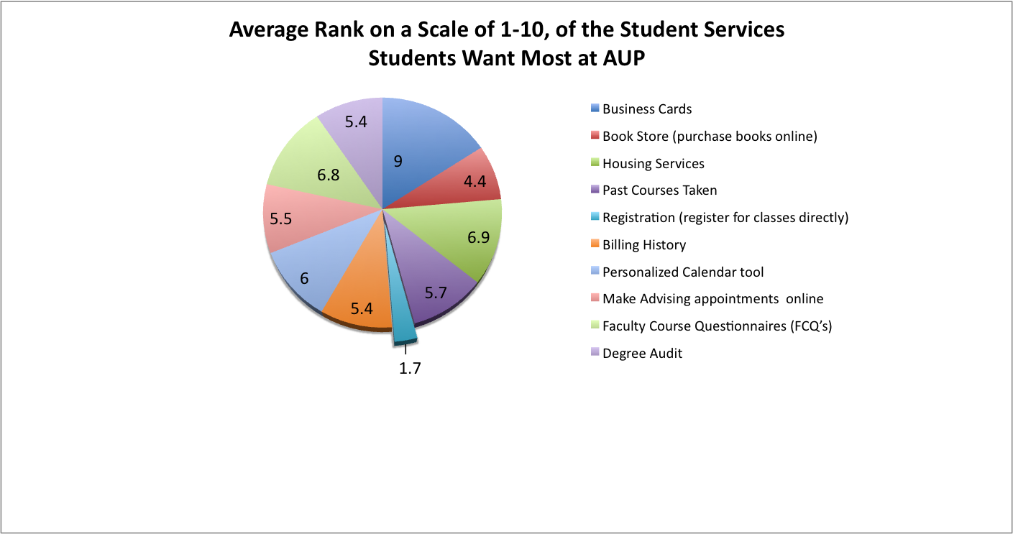

When students were asked to look at a list of 10 student services not currently offered online through my.AUP, and rank them from 1-10 (1 being the best) according to what they would like to most at the student self service that was ranked the highest was registration and the ability to register directly online. Only 22 of the participants ranked these services and 15 of those 22 or 68% of the participants gave registration a 1 making it their first choice. There was no close second or third that came after registration, the numbers that the other services ranked varied to such an extent that the averages were destroyed and all wound up somewhere in the middle. More shocking than huge win of registration was the even greater loss of business cards. Once again, 15 out of the 22 participants who that ranked these services gave this particular service, business cards, the lower mark a 10 leaving this service with an extremely high and bad average. The average of 9 on a scale of 1-10 participants shows how unimportant the participants felt this service was.
The remaining quantitative data was not graphed and it was simply the number of participants who had a prior knowledge of the distinction between aup.fr and my.aup.fr. Two students are not aware of this distinction and twenty-one students are aware of it.
There was also a great deal of qualitative data that resulted from the completed student questionnaires, specifically from the open-ended questions. The first open ended question, “which of the student services from the list provided on the questionnaire [transcripts, grades / GPA, My Files / storage, registrar, class schedule, course catalog, faculty description, advisor schedule, academic calendar, library website, cultural programs, Blackboard, AUP webmail. Bursar, club / groups, events, student affairs, writing lab, booking a classroom, careers] were you unaware were accessible prior to this questionnaire” resulted in 7 participants mentioning booking a classroom, 3 participants mentioning the bursar office, 2 participants mentioning clubs / groups, the writing lab, and careers and only one participant mentioning campus maps, faculty descriptions, advisors schedules, and students affairs. 5 participants mentioned that there were no student services that they were not previously aware were accessible, while 1 participant mentioned they were unaware that all of the services were accessible. The second open-ended question “what changes would you make so students are more aware of the accessibility of these services” produced less concrete answers. Answers were either about changing the website itself, making it easier to navigate, more organized, making the services easier to locate; or, answers were given about ways to publicize the services available through my.AUP such as through e-mails, flyers, or directly informing students. The third open-ended question “can you think of some information or services you have looked for online without being able to find it” elicited a wider variety of answers such as: a semesters courses, major requirements, building hours, faculty room extensions, calendar, letter grades, and exam times.

Discussion
A vast array of data and results were received from the completed student questionnaires that are comprehensive, diverse, and most importantly informative. Even the simplest qualitative results such as 2 of the 23 participants were unaware of the distinction and differences between my.aup.fr and aup.fr are a useful source of data. Overall, what the data we received really shows is an interest and investment on behalf of the students who by completing these questionnaires have revealed there interest in fixing the existing my.AUP website. Currently the my.AUP website does not efficiently or sufficiently meet the requirements of AUP students, a fact that became transparent after reading the completed questionnaires.

The my.AUP website was designed to aid students particularly through the student self services offered through this website. However, the data revealed that 78% of the participants were unaware of at the very least 11 of the students self services accessible through the website. Furthermore, there was only one out of the 21 student service that that every participant has used at one point or another. This student service is blackboard. I believe it’s important to examine this student service in greater detail and try to discover what is so special about this student service. Whether it is the functions it performs, the opportunities its grants, or even the accessibility of the service itself, there has to be a great reason why everyone has used this service. Along these lines I think it is also worth examining why webmail, course catalogue, the library website, grades/ GPA, academic calendar, and class schedule that also proved to be somewhat popular and frequently used and accessed student services. Without further questioning the participants in more detail, we can only guess and cannot say with certainty that these student services are so popular because they have an obligatory nature. By this we mean these services are all primarily academic and vital to the academic success of students. It seems as if so much attention is paid to these student services online out of fear and concern of performing poorly in academic areas.
Another important piece of data learned from the student questionnaires is that 35% of the student participants admitted to usually finding the information they are looking for online, normally finding this information quickly but not easily, yet finding this information more easily online then they would have on campus. Considering the student participants admitted to not being able to find information online easily it is extremely troublesome that it is still easier to find information online than on campus.

The various information gleaned from the completed student questionnaires has helped to create a concise yet accurate list of the changes that need to occur in order to benefit the exiting my.AUP website. Additionally, the requirements that AUP students want to ultimately receive through the AUP website were revealed. A fair amount of emphasis was placed on restructuring and reorganizing that manner in which student services are displayed online. The existing organization of the website does not make it easy to search for information nor does it allow for this information to be well-known and accessible to students. Secondly, there is a great desire for more direction interaction and involvement with the student services online. For instance registration and the ability to register online or make an appointment with an advisor online are examples of more involved and interactive use of student services AUP students want to feel more in control of the student services at their disposal and they want to feel like these services actually help them and guide them and exist need and rather than an additional supplementary tool.

Other stakeholders interview (Melissa Chiles)

Introduction
To get a more comprehensive understanding of the requirements needed to better serve the students, we chose to interview the Registrar’s Office who is one of the largest stakeholders after the students in the my.aup project. They play a pivotal role in the AUP community and have some of the most interactions with students on a day-to-day basis. The office is chiefly responsible for student records. Their duties include but are not limited to, processing registration requests, keeping list of schedules classes and maintaining class lists. They also enforce the rules for adding and dropping classes, and keep a permanent record of grades and school enrolment. We needed to have a clearer understanding of the specific task they performed on a daily basis as well as the duties that are important but they don’t have the time to carry out.

Method
The method we chose to employ was a focus group. We conducted a mini focus group with just two members of the registrar. We chose to use a focus group as opposed to another method such as questionnaire because it was felt we needed to have the opportunity to ask follow-up questions based on what their answers were. Asking them to follow-up questions would have been difficult to do with a questionnaire because it would have involved a level of anticipating what their responses would have been, which we were unable to do.

We let the focus group know about the goals for the project, which were to find out if My.AUP is meeting the students needs. We further explained that we were trying to make their job easier by adding features on the My.AUP website that will help maximize their productivity by eliminating time-consuming tasks. We wanted to talk to them because the play a key role in normally assisting students in some of the services we want to automate. The goal of our focus group with the registrar was to find out a bit more about what they do, especially concerning their interactions with the student. We began by asking them a few open-ended questions, which they were more than eager to respond to, and continued to ask important follow-up questions based on their responses. We were careful to allow them to talk freely with us and amongst themselves but were careful to re-direct the conversation whenever it was felt that they began to get off topic. One person asked them questions while the other observed and took notes. We held the focus group in the University café/bar, the Amex to give a relaxed environment to the participants so they would feel more open to share; we felt it was important to get them out of their office setting.

Results
The first question we asked them was what services, if available online, would make their job easier. The said that besides registration, transcripts and enrolment certificates were the top things they would like to see done online. The explained that these two things especially were mundane task that took up a lot of their time and brought a large amount of foot traffic in the office. We then asked them that out of the services they had just told us were there any were concerns about them putting online. They expressed some concern that sometimes people ask very specific request regarding enrolment certificates or transcripts that have to be dealt with in person. Another concern that was brought up was that many of the students that come to them are not familiar or unaware of the terminology for the documents they are asking for. They explained that students will come to them that they needed an unspecified form and would be unable to described to them in detail which they needed until prompted by the registrar. This then would turn into a guessing game, where the registrar would have to try and best guess what the student needed because of the student’s lack of knowledge about which forms were available and moreover what they forms where called. They also discussed their concerns about the current system for transcripts. The said that often people come to them asking for transcripts and they then direct them to order them online and said usually the student has to come back to them because of problems they encountered while trying to place an order for them. The student is either not sure the order went through or had specific instructions for them that they were unable to specify online. The registrar said that it turns out being more trouble having it online because the students have to continually come back to them with follow-up questions or request.

We then addressed the issue of grades with them and voiced that many students complain they cannot see their grades. The registrar explained that for legal reasons some students cannot see their grades because of unpaid tuition or fines and the computer cannot distinguish between who has the rights to see their grades and those who don’t. Because of this no students grades are available online. They also expressed concern that some students are not able to order their transcripts online, although they should be because the computer is unable to decipher whether or not their tuition is outstanding.

Another issue that the registrar brought up was communication with the students. They said that many students come to them asking questions before checking in obvious places like their mailbox or email. The expressed desires to have clearer communication channels and seemed frustrated that students did not check their school mailbox and electronic one more frequently. They also said that people come to them with basic questions that are indeed available online on the my.aup site but they said that the students seems unable to find this information pointing to the counter-intuitiveness of the my.aup site. They thought it to be disorganized and confusing.

Discussion
Our focus group with the registrar shed light on many improvements that needed to be made on the my.aup website. To begin with the layout of the site needs to be better, the brought up how to order a transcript you needed to go to the payment sections, which is not the first place most people would look, it would make more sense to click under academics. In regards to purchasing a transcript online, there should be a guide that lets the student know what the steps will be before they start the process of buying them ad what to expect. It would also be helpful to have a tracker that lets you know what step you are in; for example something that lets you know which step you have just completed and which steps are coming up as you go through the process of buying them.

Another requirement that clearly needs to be added is a dictionary of terms that relate to the registrar. This would help students know what they need to ask for when the visit them and help break down some of the communication problems the registrar expressed they have with students. Many American students are familiar with the vocabulary as it pertains to university functions, like transcripts, enrolment certificate, syllabus, but AUP is an international student body and over half of the student do not come from the American system ad although they speak English are not familiar with such terminology. It would also probably be helpful to place a sample of what various documents look like online, so a student can view what each document looks like and what info it contains and it will be helpful in them determining what document they need for their intents and purposes.

A frequently asked questions page would also prove useful in cutting down the foot traffic because it could provide students with a place to go online that would answer the most basic frequently asked questions. Also they said that often people come to them not knowing who to go to when really it is the bursar or academic affairs office they need to see for example. Also they mentioned that there was family tree of faces and names of the main people that worked in the administrative offices and what their job titles were. This would be useful to put online, as it would let people know not only who worked in the various office and their job title but a photo of what they looked like so they could more readily be identified. There also needs to be some sort of system that allows the computer to distinguish the students that have the right to see their grades from those who don’t.

Lastly to address the issue of communication problems they have with the students there should be a filter built into the email system, so that students can “subscribe” to various groups, which should help keep AUP spam out of mailboxes and encourage student to check their email more frequently. The registrar stressed that everything they send out to students is extremely important and usually time-sensitive as well. There could also be a session at orientation that focused on my.aup and lets incoming students know what it is for and more about the site. As for the current student a launch party could be thrown to advertise all of my.AUP’s new and improved features. This should help solve the problem of a lot of students not knowing about the site or the capabilities of it, such as using it to order transcripts.

List of Requirements
- Layout of my.aup site needs to be reorganized
  - Transcript order is in payment section not academics
- Insert a status bar during checkout that lets you know status of steps completed those to come
- Dictionary of terminology related to registrar
- Frequently asked questions page
  - They will only have to meet with students face to face for exceptional reasons
- Place sample documents online
  - Students idea of forms look like, info contained in them
- Family tree online of who people are in offices
  - Photos of them and what they do
- Something in system that allows computer to distinguish students have right to see grades from those who don’t
- Improve Communication
  - Having a filter system for email
  - Students can subscribe to various groups, and will help filter “AUP spam”
- My.aup session during orientation to let them know about site, what it does
- For current students throw a launch party for new and improved site for current students
  - Let them know all the things they can do on site

Requirements (Renee Carmichael)

Based on these six studies, we have compiled a list of requirements. This list of requirements entails 118 requirements that were given to us. To make these requirements fit with AUP, we have adapted the original requirements (changed the wording etc.) to make the requirements more relevant. The requirements that we did not understand we marked in blue. The requirements that are not useful to AUP are marked in red. All notes that are added are highlighted in yellow. Based on the studies above in section 2, we have also added several requirements that we have discovered based on our findings that are particular to AUP. The requirements list as such is complete, relevant, and pertinent to AUP.

It is important to highlight several important issues surrounding these requirements. A clear issue that arose in almost all of the studies is that there is a general lack of student knowledge and participation with the my.AUP website. Several requirements that we found are useful in helping to eradicate this problem:
# 176 Searchable dictionary with American university system terms (e.g. transcript, registrar, syllabus, sophomore, gpa, cv/resume) and all terms used online CS=5 CD=4 P=5
#190 Pages with sufficient amount of information without being too overloaded CS=4 CD=4 P=4
#191 Ability to customize some aspects of My.AUP (e.g. what is shown on the home page) CS=4 Cd=3 P=3
#192 Aesthetics must be appealing – including examples such as color scheme and recent photographs. CS=4, CD=4, P=4
#204 Have a filter system for email where students can subscribe to emails, but all important emails (i.e. registrar) will never be blocked. CS=5 CD=5 P=5
#205 My.AUP orientation session and launch party (for current students) CS=3 CD=3 P=3

The student focus group helped reveal the idea that my.AUP could benefit from a makeover so that it becomes a more attractive site such as Facebook. The requirement # 183 expresses this idea through using elements such as scrolling photos from recent events on the first page of my.AUP. This aesthetic appeal is felt to attract AUP students. Aside from these specific requirements, all requirements will help to encourage AUP students to see the value of the my.AUP website (e.g. adding grades to the website, reorganizing the information so it is more logically found, making information more visible etc)

Another important issue to highlight is that students wished to be able to have more control over their experience at AUP. This includes being able to change their photo and personal information. It also included the basic ability of being able to access information and forms when they wanted instead of having to rely on the business hours of AUP. This personalization also comes with its downside as students also expressed concern of who has access to information that may be placed online. For example, if a student creates a personal portfolio of their work, they do not necessarily want it to be available to all professors. (see requirement #11).

In general, most of these requirements relate to student’s frustration in that there is no clear way to understand and use my.AUP. It appears to the students as inconsistent. With such diversity at AUP, the my.AUP website needs to find a way to use these requirements in a design that will take into account this diversity and become a norm of not many different ideas and inconsistencies but of AUP ad the characteristics of AUP itself. The requirements such as a the online dictionary are an example of this representation of AUP through the my.AUP website. (See requirement # 176).

Based on this study and all its experiments, this list of requirements, mixed with a good design and organization, will help to make a website at AUP that is more user friendly, attractive, and efficient which will benefit all the stakeholders at AUP.

Prototype

Approach (Emily Nathanson)
To design our prototype we collected data primarily limited to student services, through the six students described above. The combined data that these forms of analysis allowed us to collect enabled the class as a whole to develop a list of requirements to aid us in the construction of our prototype. As a class we physically drew out what we would ideally want the new my.AUP web page to look like in terms of content. Due to time constraints, however, we have not developed fully a clear design of this website. We relied heavily on the feedback and data received from our extensive analysis process as well as contributed some of our personal opinions and experiences with the my.AUP website and others of its kind. From there, our ideas and notes were translated into the html code in Dreamweaver that became our prototype

Working prototype and Screenshots (Jeremie Simon)

Appendix

Diary Study

Diary study
If we haven’t covered diary studies in class, please see p. 338 – 340 of your book.

Students self services.

The objective of this study is to gather a better understanding of the type of self services students would like to have in the new ERP (Enterprise Resource Planning) system.

During a full week you should keep track of the information you need for your normal functioning at AUP.

With this diary study we want to answer the following questions:

- What is the information needed by AUP students in order to work well on campus?
- Is this information available at the right time in the right place?
- What are the main problems, if any, encountered in accessing this information?

During one week you should fill in the diary supplied below. Please try to be as precise and detailed as possible. You should also ask a friend to do the same (he/she should be an AUP student).

If you find it complex to carry the diary around and mark entries each time you access information, you could fill in the diary in the evening and during the day keep notes, take picture, record sounds, anything that will help you remembering your information access activities.

Please also make notes on how well the diary study worked, what was difficult to do, what was unclear, are there other questions that we should have asked, are there questions that give us data we cannot use, etc.

NAME _________________________________________________________________ Please use the verso if you don't have enough space in any of the cells

Date/time | Location | Access | Information accessed | Availability | Problems/ comments

Usability Study

Usability Study: Task Observation for MyAUP:

For this observation, students will be logged into MyAUP and asked to perform the tasks listed on the table. One of the two observers will count the number of clicks it takes for the student to reach the destination and time how long it takes for the student to get to the destination. Please ask the student to perform one task after another, without taking them back to the main MyAUP page.

Please fill in the following table:

Key:
To find a file on your personal drive:
- My Files (top menu) → Password
To find your unofficial transcript:
- Academics (left menu) → Unofficial Transcript
To find printing credit:
- My Services (left menu) → Printing → Add printing credit
To find mailbox number:
- My Profile (left menu) →Student Information

Focus Group
Diary Study Focus Group Script
Thank you for agreeing to participate in today’s focus group. Please fill out the consent form and questionnaire. We will be discussing the AUP student self-services, which include information relative to the bursar, the registrar, personal student information, etc, and how these services can be accessed. It is also important to note that AUP has two main sites: myaup and aup.edu. Accessible information may vary depending on the site.

All student self-service information is available on myaup, do you find it easy to find/navigate?

How did you find AUP? Was it online? What were your impressions once you consulted the website?

For which services do you feel you’d like to talk to someone in person vs. online?

All personal academic profiles (including academic standing, course schedules, status, gpa, etc) are available for students online, do you find it easy to access?

Do you agree that student, faculty, and campus information is updated quickly and accurately?

How do the online student self-services at AUP compare to other universities?

Is there anything missing from the current database that you would like to see in the future? What would you add, change, or amend if you could in terms of the amount of human and/or computer interaction with the AUP student services? Do you feel you have total control over any all services?

Do you feel that your private information is protected? Would you like more control and interaction options with the online services?

Do you agree that both myaup and aup.edu are easy to access/navigate overall? Please give examples.

Do you find the AUP online student services to be aesthetically pleasing?

Thank you for your time. If you have any further comments, please feel free to email us at croda@aup.edu.

Student Questionnaire
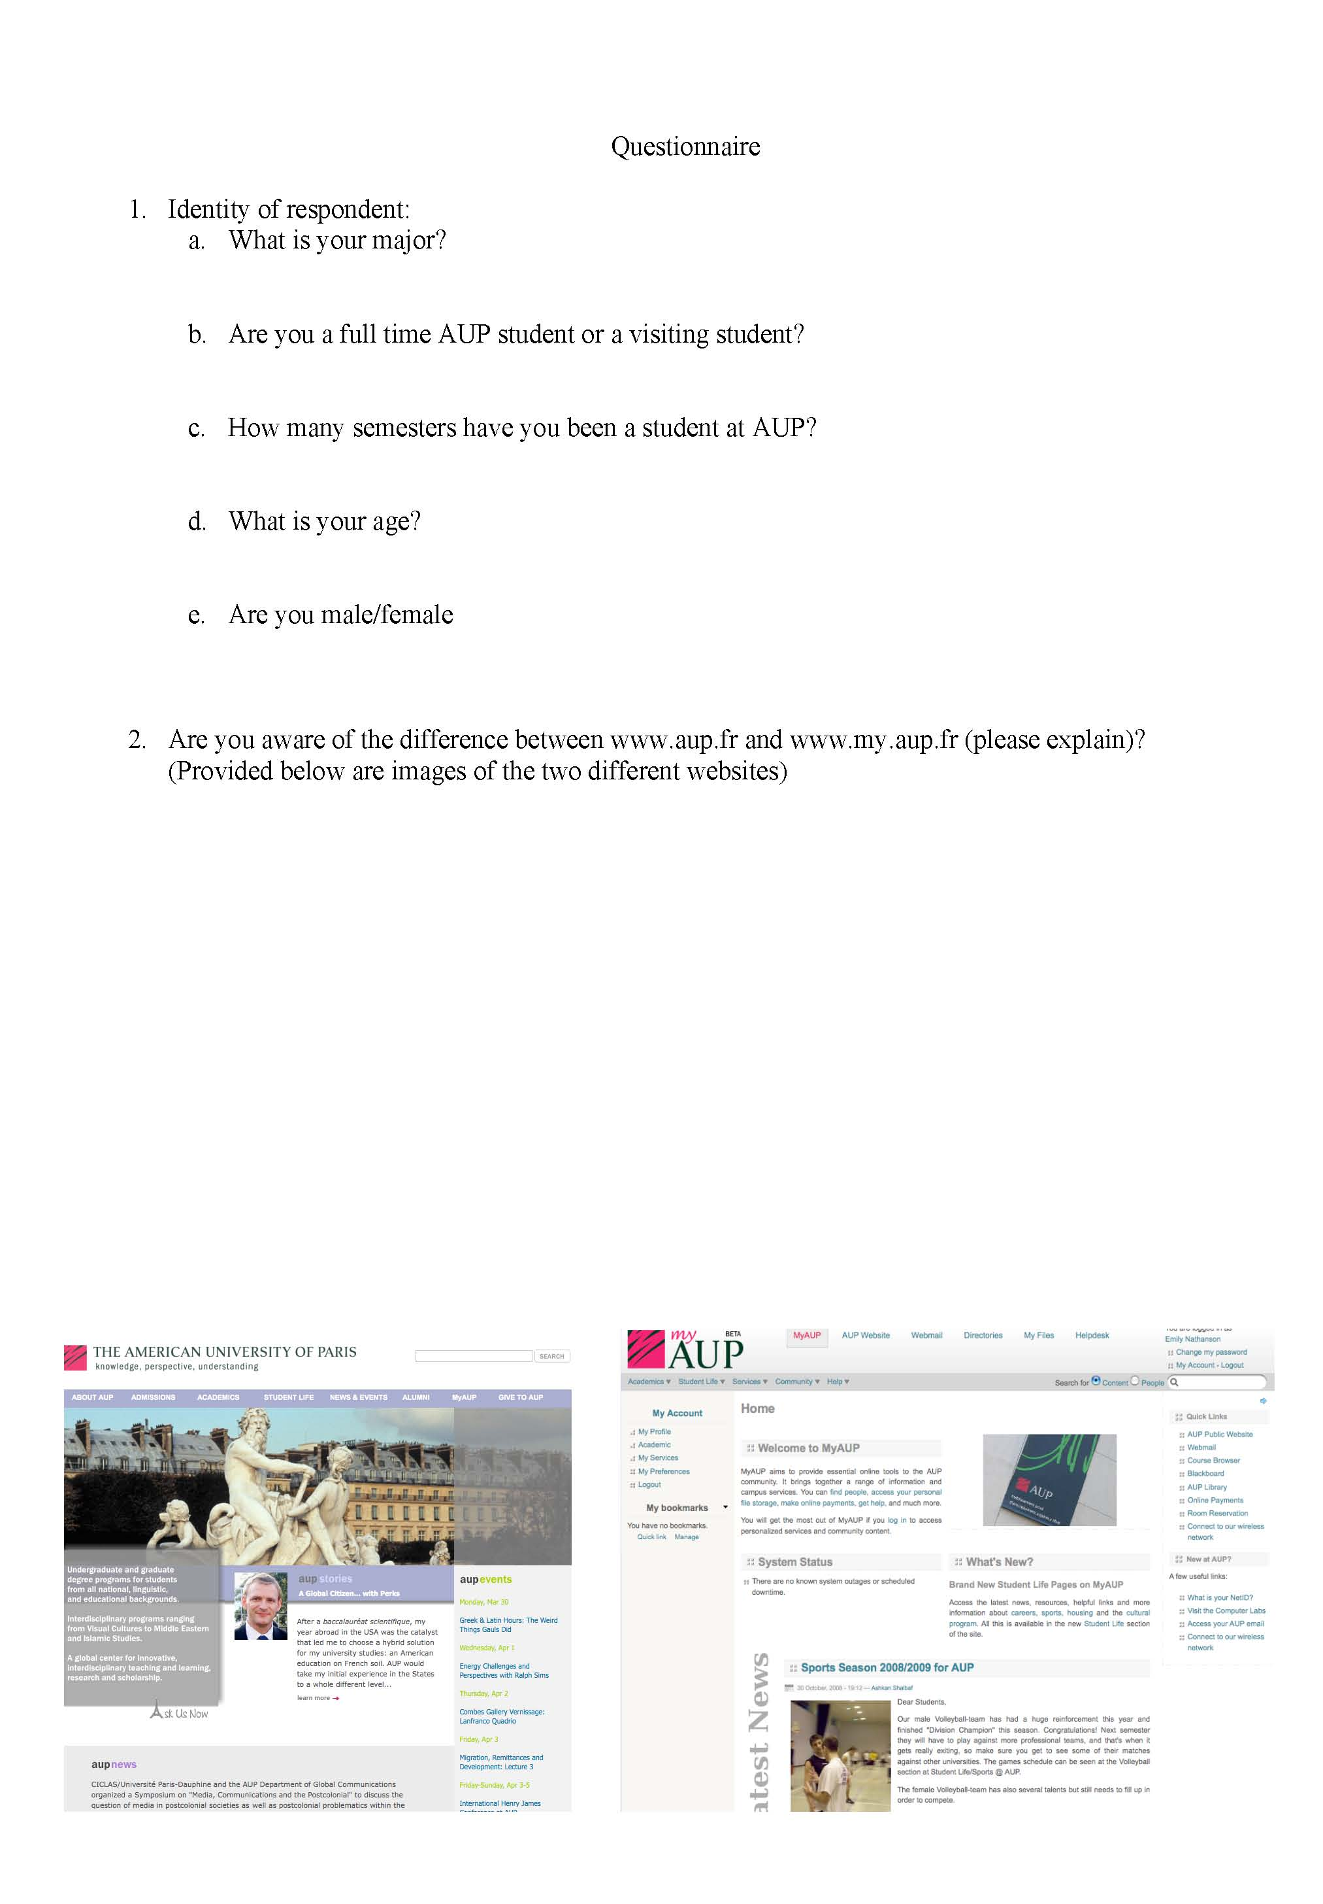
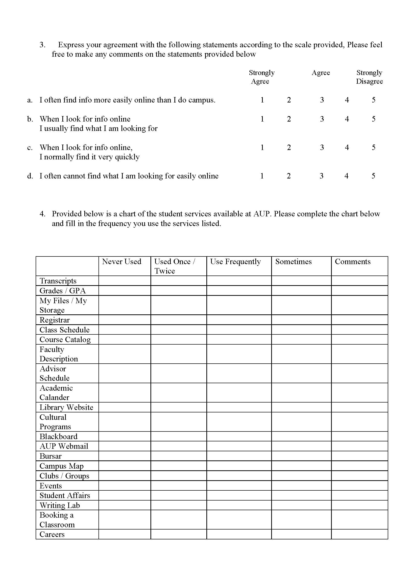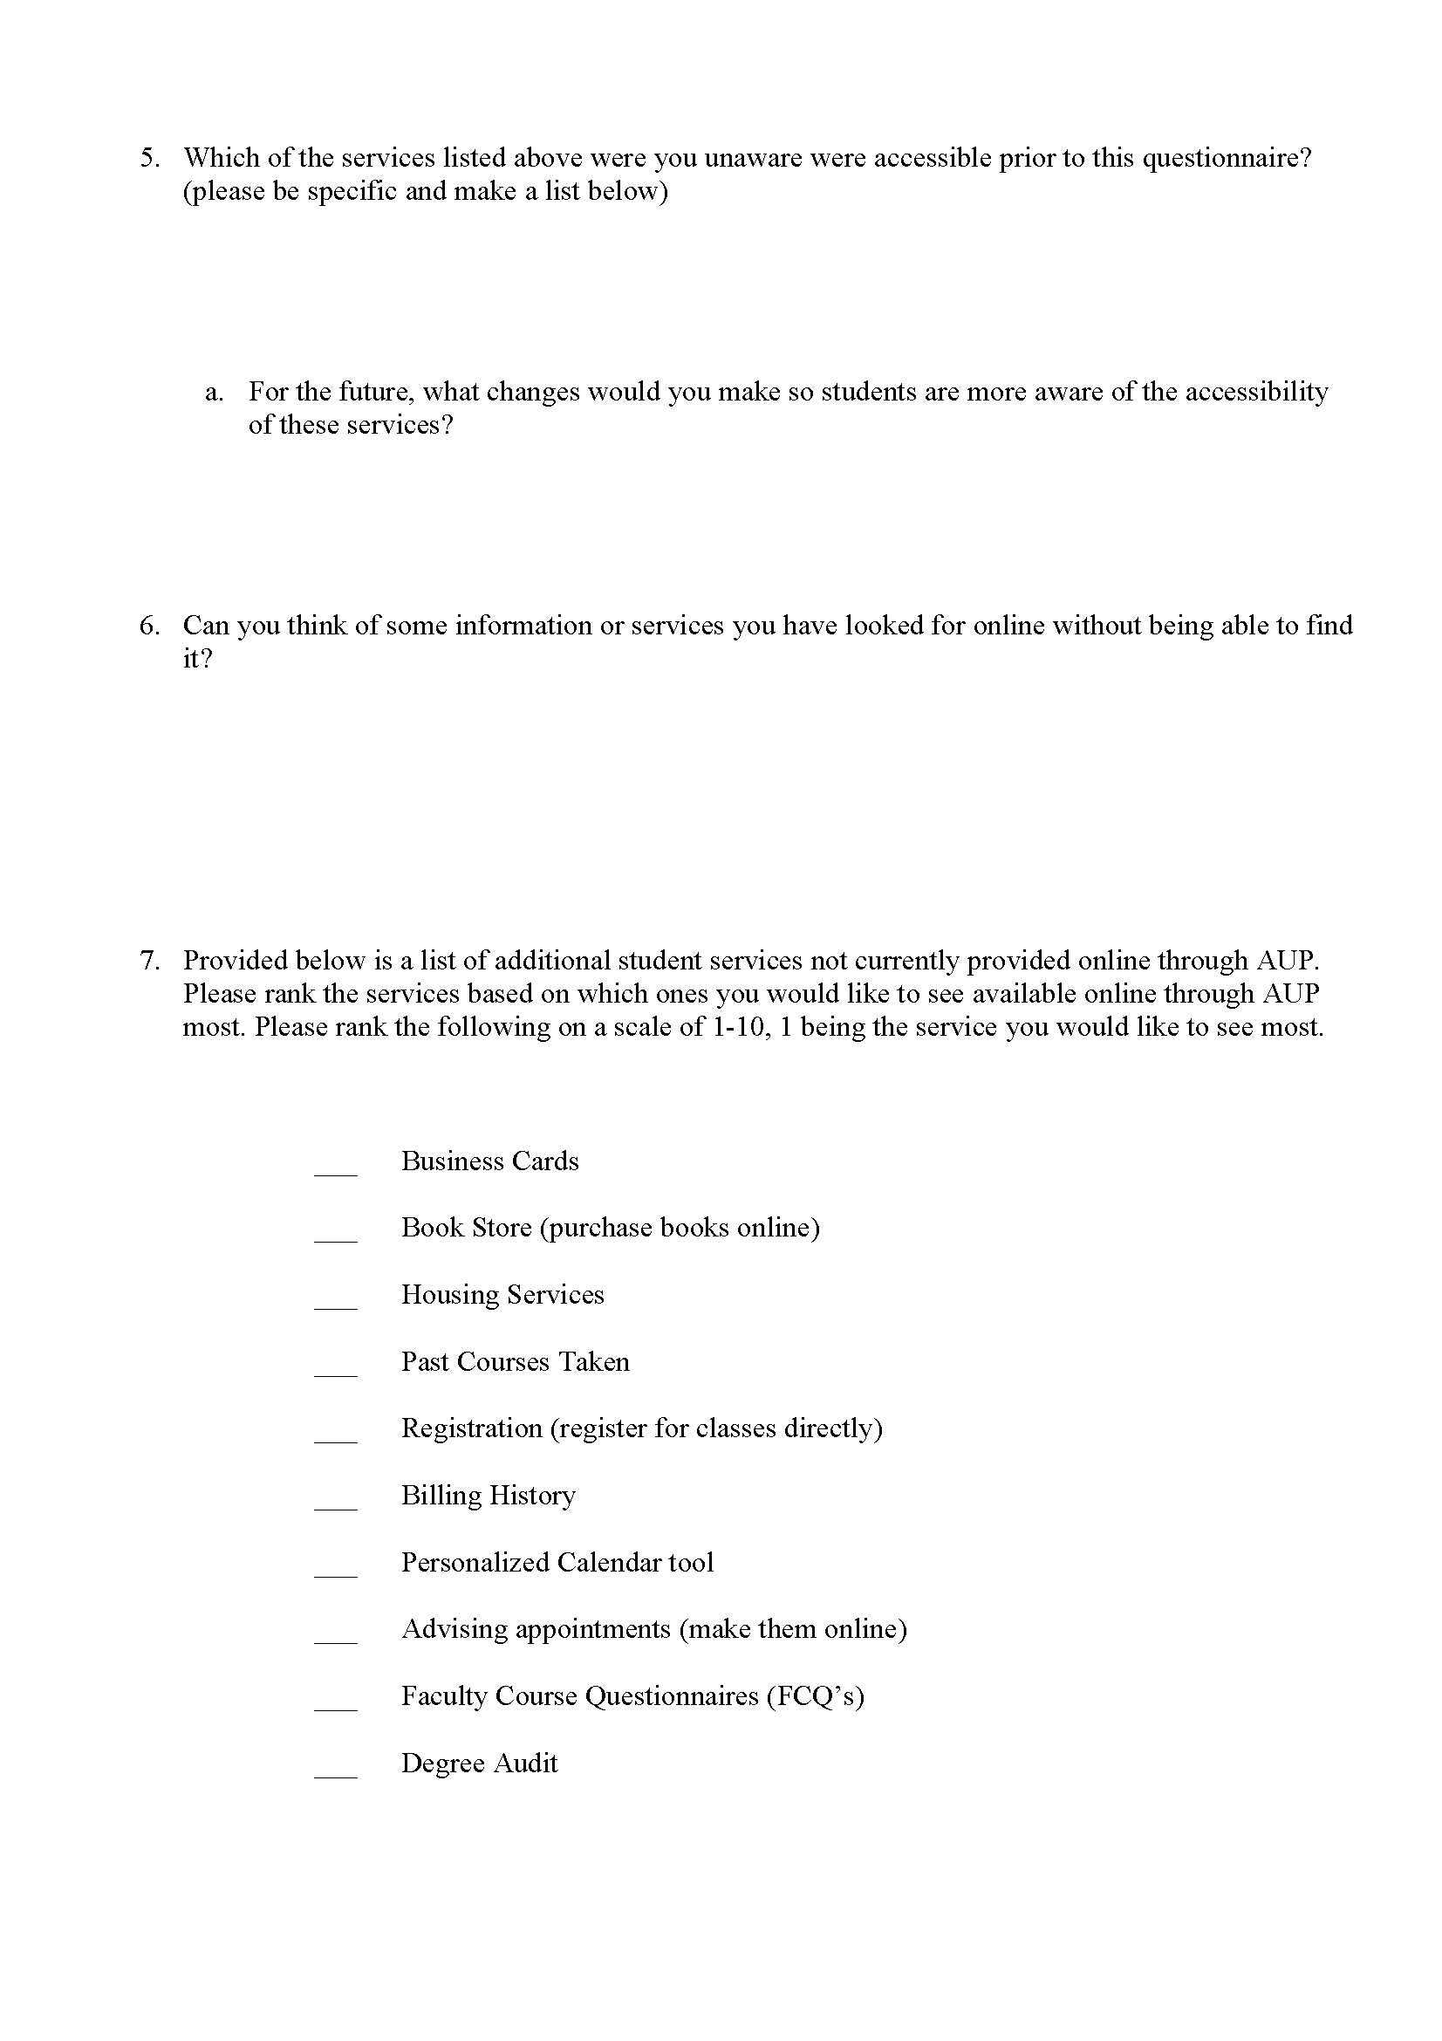

You can indicate a time span
Location: place where you have accessed the information (e.g. library. Lab, classroom, home)
If you have used a device to access the information (e.g. telephone, computer) please indicate it here. If you have asked the information to someone please indicate the person who gave the information. If you have gathered the information from a board, poster, etc. indicate it here.
Describe the information you have accessed, e.g. "CS348 course location", "address of the library", "Prof. Roda’s office number", …
Availability: did you have to move to a specific place to access the information (for example from the entrance to Grenelle to the lab, from one building to another one) or was the information available in the place you needed it? If you had to move please indicate the time it took to reach the place.
Problems/Comments: please indicate any problems you encountered in accessing the information or any comments you have (e.g. unusual situations)

